**PROJECT REPORT**

**ON**

**STOCKS FORECASTING AND**

**VISUALIZATION USING DASH**



**SUBMITTED BY**

**TRIBE L MEMBERS**

**AMBRESH**

**HEENA NAWAZ**

**H ANJANA**

**GOURI POTDAR**

**VISHAKA RATHOD**

**ABSTRACT**

In the modern financial market, the most crucial problem is to find an essential approach to outline and visualize the predictions in stock-markets to be made by individuals in order to attain maximum profit by investments. The stock market is a transformative, non-straight dynamical and complex system. Long term investment is one of the major investment decisions. Though, evaluating shares and calculating elementary values for companies for long term investment is difficult. Stock price forecasting is a popular and important topic in financial and academic studies. Stock investments provide one of the highest returns in the market. Even though they are volatile in nature, one can visualize share prices and other statistical factors which help the keen investors to carefully decide on which company they want to spend their earnings on. In this project we have created a single page web application using the Dash library (of Python), we have made dynamic plots of the financial data of a specific company by using the tabular data provided by yfinance python library. On top of it, we have used machine learning algorithm to predict the upcoming stock prices.

**CONTENTS**

**ABSTRACT**

**CONTENTS**

**1. INTRODUCTION**

* **Motivation**
* **Problem statement**
* **Objective**

**2. DATA VISUALIZATION**

* **What is Data Visualization?**
* **Goal of Data Visualization**
* **Data Visualization in Stock Market**

**3. REQUIREMENTS**

* **Hardware Requirements**
* **Software Requirements**
* **Python libraries and tools used**

**4. PROPOSED SYSTEM**

* **Project Stages**
* **Approach used**

1. **PROJECT OUTCOMES**
2. **CONCLUSION**

**REFERENCES**

**1. INTRODUCTION**

Exchanging the stocks on money markets is one of the significant speculation exercises. Already, scientists developed different stock examination systems that could empower them to envision the bearings of stock esteem development. Predicting and foreseeing of significant future cost, in perspective of the present cash related information and news, is of colossal use to the financial pros. Financial masters need to know whether some stock will get higher or lower over a particular time-period. To obtain the accurate output, the approach used to implement is machine learning along with supervised learning algorithms. Results are tested using different types of supervised learning algorithms with a different set of features. Stock investment decisions require time, knowledge and awareness including historical data, the stock market contains a huge amount of data that varies over time. Stock prices are inﬂuenced by various factors ranging from the performance of the company itself to the conditions of the economy in general. Thus, to manage investment portfolios, stock market data has to be analyzed regularly to identify potential relationships between various stocks, hence to adjust investment based on related stocks trends. A picture is worth a thousand words presenting data in visual form can assist humans in exploring deep insight of vast amounts of complex raw data, especially when people have limited knowledge of the data. Visual representation is one of the most eﬃcient ways to assist investors to have a clear overview of movements of the stock market, as well as providing a deeper understanding of each individual stock.

* **MOTIVATION:** Predicting this stock value offers enormous profit opportunities which are a huge motivation for research in this area. Even a fraction of a second's knowledge of a stock's worth can result in large earnings. Similarly, in the repeated context, a probabilistically- correct prediction might be highly profitable. This attractiveness of finding a solution has prompted researchers, in both industry and academics to find a way past the problems like volatility, seasonality and dependence on time, economics and the rest of the market. However, the platform's prices and liquidity are highly unpredictable, which is where technology comes in to aid.
* **PROBLEM STATEMENT:** The accuracy of the existing stock market prediction models is relatively low because only a small data-set is used for the training; the results will be less accurate. There is still a need to continually explore more new features that are more predictable. Even though multiple algorithms exist, there is no real-life implementation of these ideas for the benefit of people. Efficient algorithms should be made available with easy accessibility and interface.
* **OBJECTIVE:** We will be creating a single-page web application using Dash (a python framework) and some machine learning models which will show company information (logo, registered name and description) and stock plots based on the stock code given by the user. Also the ML model will enable the user to get predicted stock prices for the dates inputted by the user.

**2. DATA VISUALIZATION**

* **What is Data visualization?**

Data visualization refers to the techniques involved in graphically representing data, using visual elements like charts and graphs to spot trends, patterns, and outliers, for quick insights, and to help in real-time decision-making. It's increasingly important in today's world to understand the overwhelming volume of data being generated by businesses every single day.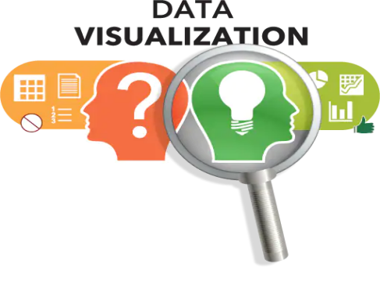

### **Why is data visualization important?**

### Because of the way the human brain processes information, using charts or graphs to visualize large amounts of complex data is easier than poring over spreadsheets or reports. Data visualization is a quick, easy way to convey concepts in a universal manner – and you can experiment with different scenarios by making slight adjustments.

* Data visualization can also:
* Identify areas that need attention or improvement.
* Clarify which factors influence customer behavior.
* Help you understand which products to place where.
* Predict sales volumes.
* **Goal of Data Visualization:** the visual representation of data, is more scientific than artistic in our modern world. The main goal of data visualization is effectively, efficiently, elegantly, accurately as well as meaningfully communicating information. It fulfills its objectives only if it encodes the given input in such a manner that our eyes can recognize and our brain can comprehend.
* **DATA VISUALIZATION IN STOCK MARKET.**

Data visualization helps traders when making decisions quickly and enables them to easily synthesize large amounts of complex information.

* **How Data Visualization Can Improve Decision Making.**
* **Illustrating patterns:** Visuals are exceptional at presenting patterns. [The human mind is wired to recognize patterns](http://bigthink.com/endless-innovation/humans-are-the-worlds-best-pattern-recognition-machines-but-for-how-long), but it’s hard to make sense of those patterns when they appear as individual data points, such as in stock prices that fluctuate over a period of months. However, if those data points are plotted onto a linear graph, it’s much easier to spot the highs and lows, and make a guess at how that pattern could unfold in the future.
* **Highlighting multiple variables:** Data visuals also allow you to highlight and control for multiple variables. Depending on your goals, this could help you factor multiple variables into your decision all at once, or help you drill down so you exclusively focus on one variable’s effects on your investments. Either way, you can use visuals to make more informed decisions.
* **Reducing complex subjects:** One of the biggest advantages of data visualization is its ability to make complex subjects easier to understand, which is [imperative in this age of big data](https://www.sas.com/en_us/insights/articles/analytics/data-visualization-a-wise-investment-in-your-big-data-future.html). There are too many independent data points for any one person to track, but an automated platform can easily create a digestible version that appeals to your visual senses. Granted, not all financial topics are reducible to a simple conclusion, but visualization can make things more approachable, at the very least.
* **Adding customizing ability:** Most data visualization platforms have multiple controls that help a user customize their graphs and get exactly the visual they need to make a given decision. For example, you might be able to add or subtract specific variables, extend or contract the date range, or overlay competing subjects to get a clearer picture of what’s going on.
* **Easing communication.** If you’re investing with a partner, you should know data visuals also make it easier to communicate complex topics. Running a point-by-point analysis about each independent variable in your data set isn’t going to go over well with a non-technical audience; but a graph can easily highlight your most important takeaways.

**3. REQUIREMENTS**

* **Hardware Requirements:**
  + RAM: 4 GB
  + Storage: 500 GB
  + CPU: 2 GHz or faster
  + Architecture: 32-bit or 64-bit
* **Software Requirements:**
  + Python 3.5 and above in Visual Studio code
  + Operating System: windows 7 and above or Linux based OS or MAC OS
* **PYTHON LIBRARIES AND TOOLS USED:**
  + - * numpy library is used for multi-dimensional array operations.
      * pandas is used for creating DataFrames to efficiently manage the data.
      * yfinance is a library that allows us to fetch financial data of a company (since its listing in the stock market) from its stock code directly.
      * gunicorn and lxml libraries will be used for the application's deployment i.e. to host the app on a target server.
      * sklearn and scikit-learn are tools used in the development of Machine Learning (ML) models.
      * Dash is an open-source Python framework used for building analytical web applications. It is a powerful library that simplifies the development of data-driven applications. It’s especially useful for Python data scientists who aren’t very familiar with web development. Users can create amazing dashboards in their browser using dash.
      * Plotly is an open-source library that provides a list of chart types as well as tools with callbacks to make a dashboard.
      * Flask is a small and lightweight Python web framework that provides useful tools and features that make creating web applications in Python easier.
      * dash_core_components: It is used for making beautiful charts, other visual components such as selectors, drop-downs, dates, and other visualizations.
      * dash_html_components: It includes various HTML tags for designing the dashboards. Dash HTML Components are similar to HTML syntax-es, so try relating the two syntax together.
* **DASH in Python:**
* **What is Dash?**

Dash is a python framework created by plotly for creating interactive web applications. Dash is written on the top of Flask, Plotly.js and React.js. With Dash, you don’t have to learn HTML, CSS and Javascript in order to create interactive dashboards, you only need python. Dash is open source and the application build using this framework are viewed on the web browser.\

* **Building blocks of Dash:**
* Dash applications are made up of 2 building blocks : Layout and Callbacks
* Layout describes the look and feel of the app, it defines the elements such as graphs, drop downs etc and the placement, size, color etc of these elements. Dash contains Dash HTML components using which we can create and style HTML content such as headings, paragraph, images etc using python. Elements such as graphs, drop downs, sliders are created using Dash Core components.Callbacks are used to bring interactivity to the dash applications. These are the functions using which, for example, we can define the activity that would happen on clicking a button or a drop down.

**4. PROPOSED SYSTEM**

A single-page web application using Dash (a python framework) and SVR(Support Vector Regression) machine learning model which will show company information (logo, registered name and description) and stock plots based on the stock code given by the user. Also the

ML model will enable the user to get predicted stock prices for the date inputted by the

user.

* **PROJECT STAGES**

**Fig: 4.1. Project Stages**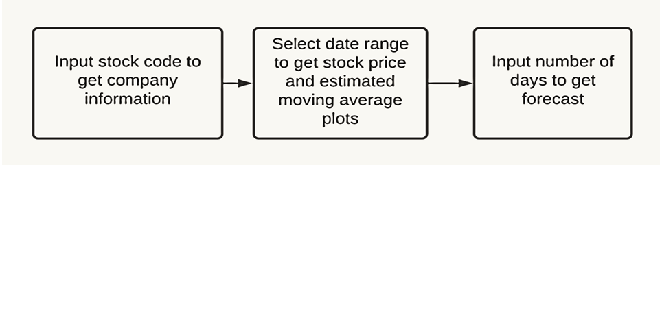

* **APPROACH USED**
  + Install all the required python libraries and framework
  + Create a basic website layout.The basic layout of the application will be built using Dash. Create the main website's structure using mainly Dash HTML Components and Dash Core Components.
  + Enhance the site's UI by styling using CSS.Using CSS we will style our web page to make it look more neat and user friendly.
  + Generate plots of data(company’s information) using the plotly library of Python. By fetching the data using yfinance python library.We are going to use the yfinance python library to get company information (name, logo and description) and stock price history. Dash's callback functions will be used to trigger updates based on change in inputs.

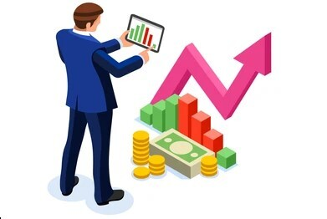

* + Implement a machine learning model(Support Vector Regression) to predict the stock price for the dates requested by the user. Using the support vector regression (SVR) module from the sklearn library. Fetch the stock prices for the last 60 days. Split the data-set into a 9:1 ratio for training and testing respectively. Use the rbf kernel in GridSearchCV for tuning your hyper parameters. Then, train the SVR model with the training dataset .
  + Test your model's performance by using metrics such as Mean Squared Error (MSE) and Mean Absolute Error (MAE) on the testing dataset.
  + Use the following command in the terminal of the working directory to run your Dash app's server locally - $python filename.py

1. **PROJECT OUTCOMES**

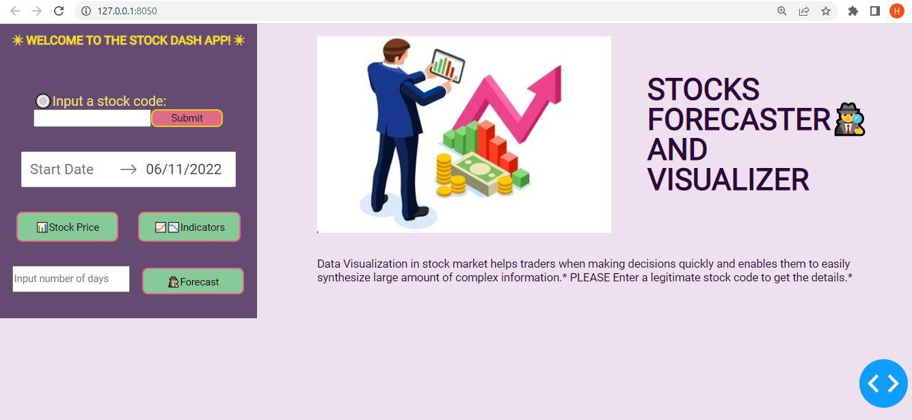

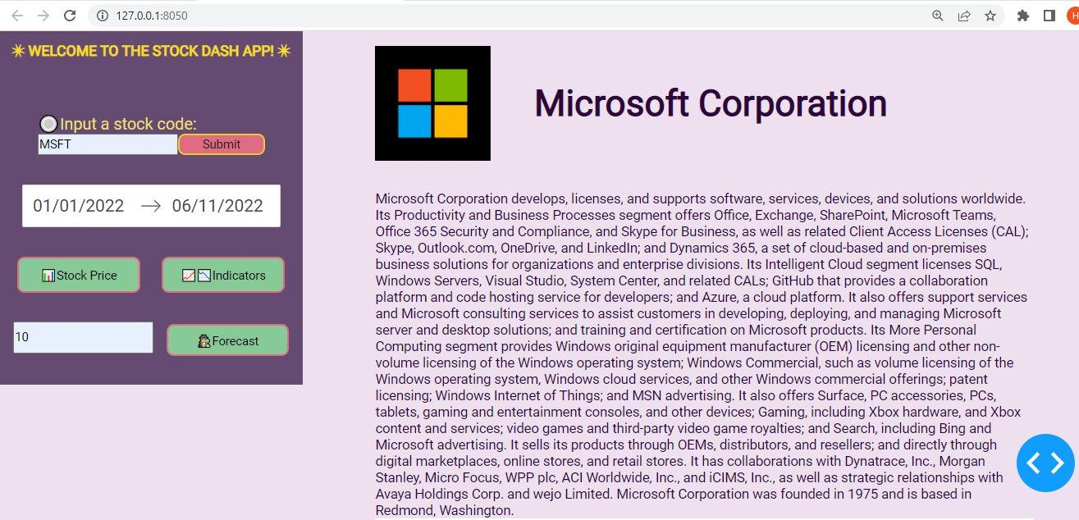

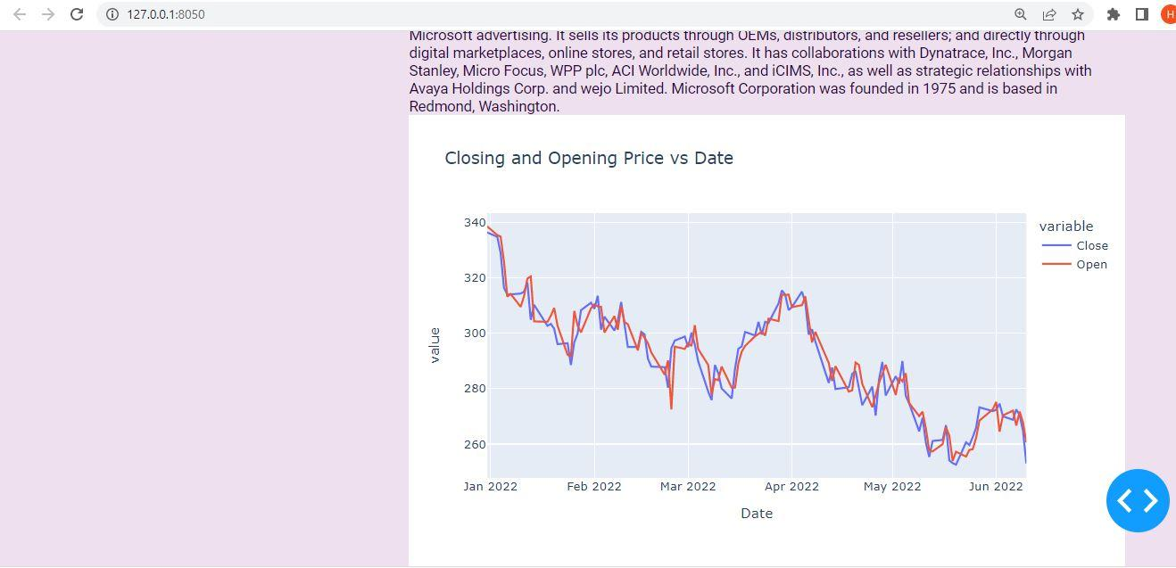

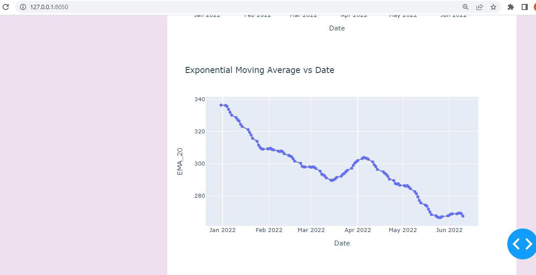

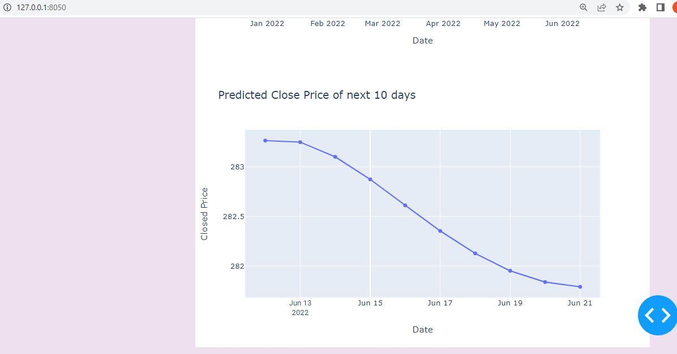

**REFERENCES**

* [**Part 2. Layout | Dash for Python Documentation | Plotly**](https://dash.plotly.com/layout)
* [**Dash HTML Components | Dash for Python Documentation | Plotly**](https://dash.plotly.com/dash-html-components)
* [**Dash Core Components | Dash for Python Documentation | Plotly**](https://dash.plotly.com/dash-core-components)
* [**CSS Tutorial**](https://www.w3schools.com/css/default.asp)
* [**A Complete Guide to Flexbox | CSS-Tricks**](https://css-tricks.com/snippets/css/a-guide-to-flexbox/)
* [**Part 3. Basic Callbacks | Dash for Python Documentation | Plotly**](https://dash.plotly.com/basic-callbacks)
* [**Build A Stock Prediction Program**](https://www.youtube.com/watch?v=EYnC4ACIt2g)
* [**Python LSTM (Long Short-Term Memory Network) for Stock Predictions | DataCamp**](https://www.datacamp.com/tutorial/lstm-python-stock-market)
* [**An introduction to Grid Search. This article will explain in simple… | by Krishni | DataDrivenInvestor**](https://medium.datadriveninvestor.com/an-introduction-to-grid-search-ff57adcc0998)
* [**Plotly Express**](https://plotly.com/python/plotly-express/)
* [**Hands-On Guide To Using YFinance API In Python**](https://analyticsindiamag.com/hands-on-guide-to-using-yfinance-api-in-python/)

